Session 19 - APIs Introduction: Task Report

Task 1: GET First 5 Post Titles
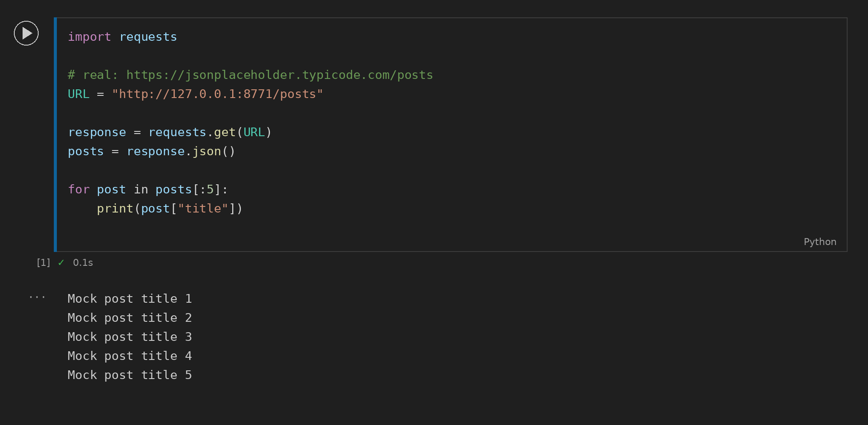

Task 2: Dictionary to JSON
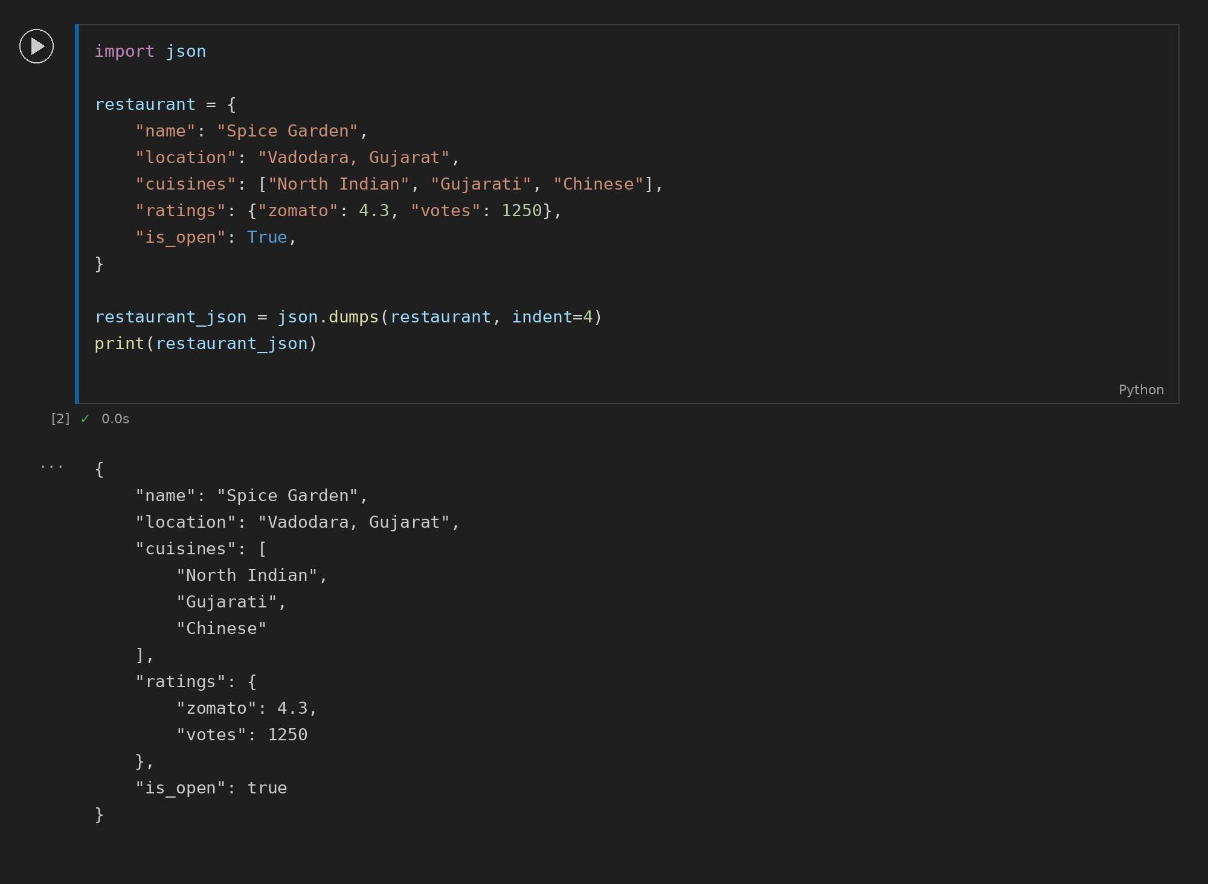

Task 3: POST New Playlist
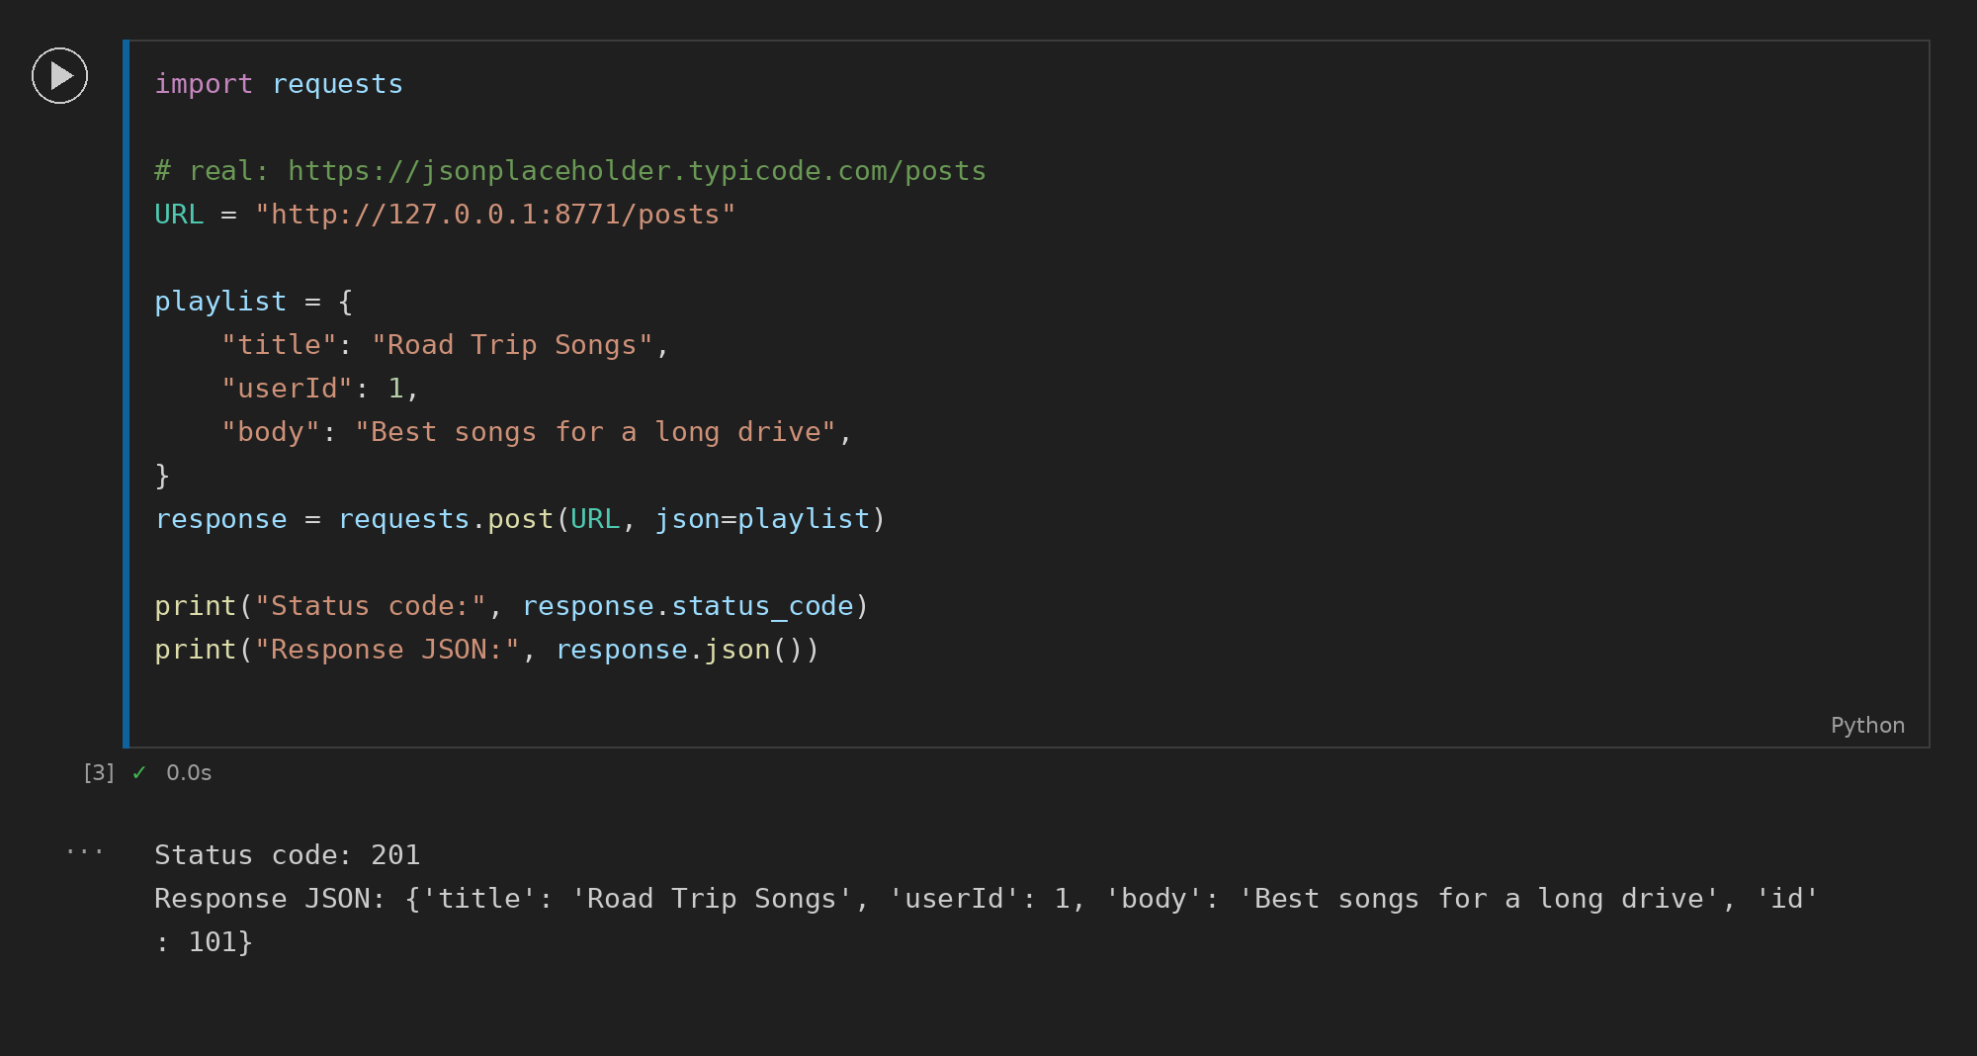

Task 4: Filter Posts by userId
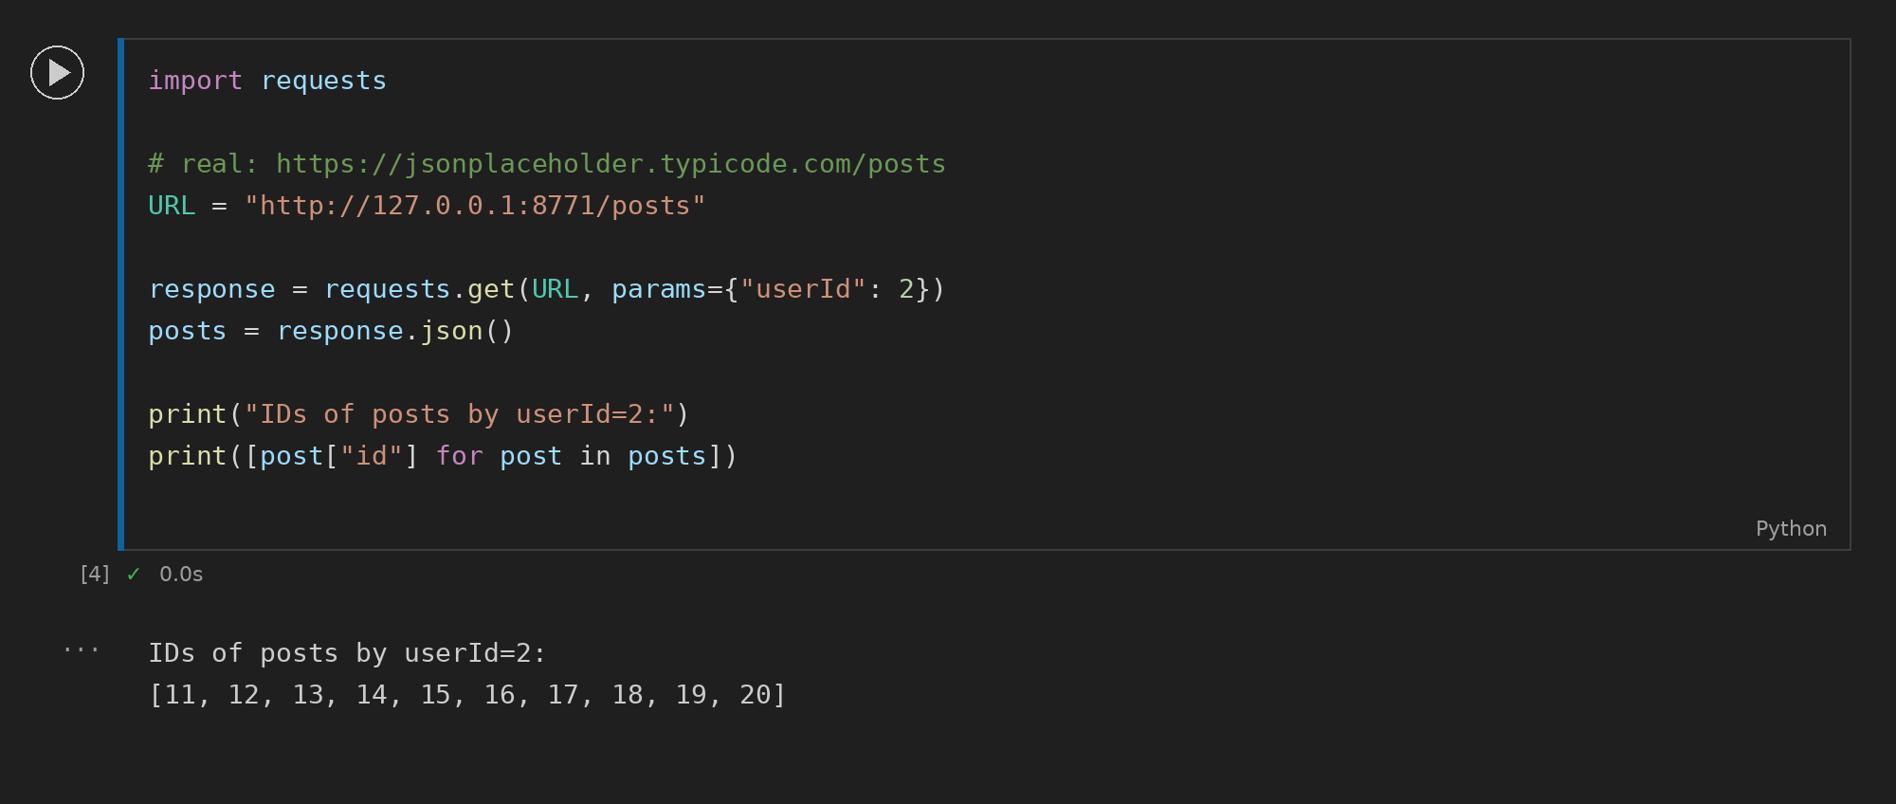

Task 5: Custom Headers
